MODELLING OF INVERTER BASED

PHOTOVOLTAIC SYSTEM

Ankita Kumari

# *Abstract*— The paper describes the modelling and analysis of an inverter based photovoltaic (PV) systems, which is an important component for improving solar energy conversion under changing weather circumstances. The micro inverter, built using MATLAB Simulink, uses control algorithms grounded on this Incremental Conductance technique for the Maximum Power Point Tracking (MPPT). This system configuration includes a boost converter with MPPT capability, a filter, and an H-bridge inverter controlled by a PI controller. This arrangement successfully adapts for fluctuations in solar irradiation, ensuring a steady output at the boost converter step. The DC voltage is increased to about 300V, allowing H-bridge inverter to produce a constant 220 Vrms line voltage output. With a total power output of around 315W, this micro inverter design displays efficient and dependable PV power conversion, making it ideal for small-scale applications.

1. **INTRODUCTION**

The introduction classifies energy resources into nuclear, fossil fuel, and renewable sources. Renewable energy (RE), which includes hydropower, solar, wind, and geothermal, accounts for 14% of global energy consumption and is gaining popularity as fossil fuels become depleted and climate concerns rise. Solar photovoltaic (PV) systems are acclaimed for their environmental friendliness, fuel-free operation, and durability.

Solar cells come in three generations: polycrystalline and monocrystalline silicon (first generation), thin solar cells (second generation), and advanced thin-film technologies (third generation). Monocrystalline cells are more efficient, but have a higher cost. PV systems can be freestanding (with batteries) or grid-connected (without batteries).

PV systems need inverters to convert DC to AC electricity. There are three types of inverters: central, string, and micro. Central inverters can manage big PV plants; however, they are inefficient under partial shadowing. String inverters alleviate shading difficulties by offering separate MPPT control for each string. Micro inverters linked to each PV panel completely eliminate shading difficulties, increasing system output but raising expenses.

This research utilizes MATLAB Simulink to simulate a micro inverter and evaluate its performance under different solar irradiance conditions. It uses two control algorithms: incremental conductance MPPT for the DC-DC converter and a PI-controlled H-bridge inverter for DC-AC conversion.

The system is meant to run at 220V RMS at 50 Hz, which is ideal for grid connection, however it is currently operating in island mode. Future research will incorporate phase tracking for grid integration.

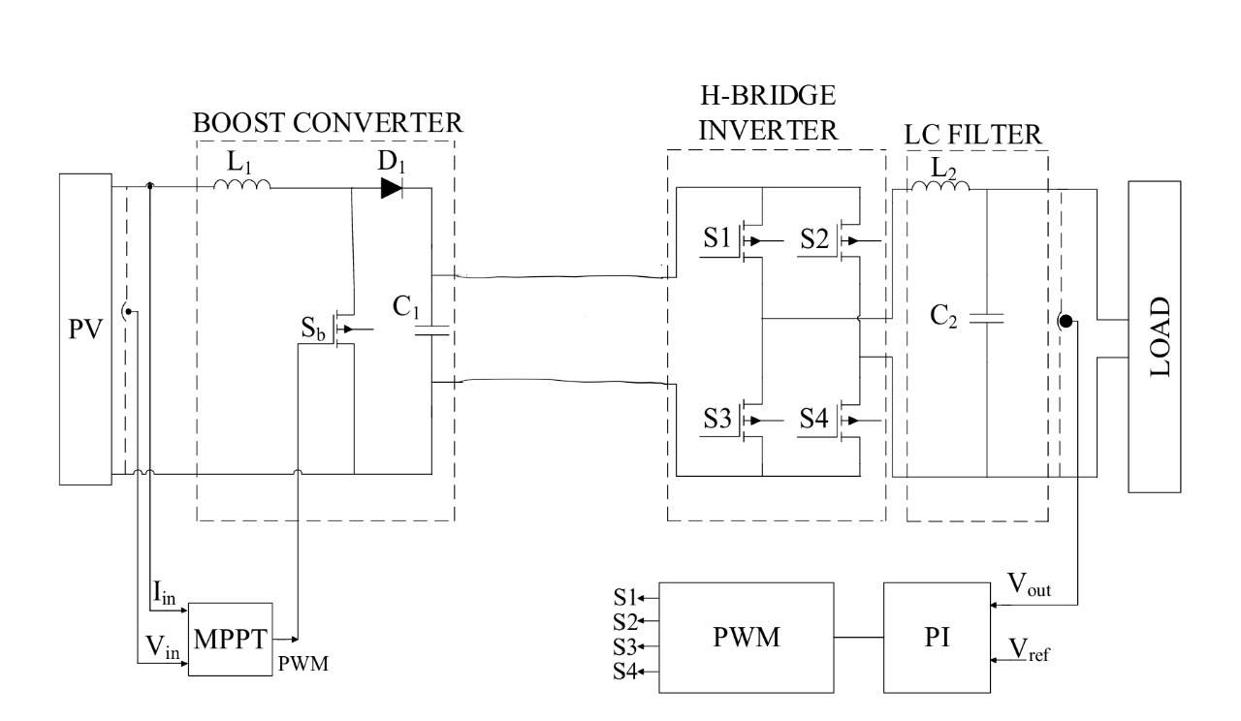

# Fig.1 Structure of inverter-based PV

This inverter consists of two forms: the very first is a boost converter, and the second one is an H-bridge inverter. The boost converter, which includes and Inductor (L1), Switch (SB), Diode (D1), and condenser (C1), steps up the input voltage to a higher level. This stage operates with an IGBT; switch controlled by a closed-loop MPPT (Tracking of maximum power point) algorithm. The H-bridge inverter, made of four IGBTs, converts the DC voltage into AC with a PWM control driven by a PI controller.

The micro inverter is designed for a 315W output, with an input voltage of 55V to 60V DC and a result of 220V RMS Alternating current. The data input and result voltages are observed by the software for control, while this algorithm optimizes the DC input for maximum power extraction from the PV panel.

An LC filter Is positioned near the output to lessen harmonics and create a clean sine wave. For AC voltage generation, the H-bridge inverter uses Sinusoidal Pulse Width Modulation (SPWM) controlled by a PI controller, producing a 220V RMS output at 50Hz. The micro inverter is tested with a l PV panel, and its performance has been governed by the MPPT controller, which adjusts the duty cycle to ensure efficient power conversion. The design ensures voltage isolation and stable operation for single-phase applications.

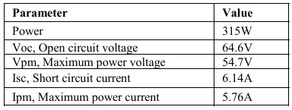 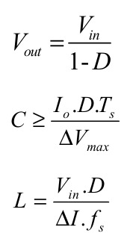

Table 1. Parameters of PV panel **Formulae**

1. **Boost Converter**

A boost converter is a type of DC-DC power converter that converts the input voltage to a higher output voltage while preserving the same polarity. It works by a switching mechanism that typically includes a switch (similar to a transistor), a IGBT, an inductor, and a condenser. During operation, this switch cycles between on and off states: when on, the inductor stores energy from the input voltage, and when off, the inductor releases its stored energy to the output, raising the voltage above the input. Boost converters are widely employed in applications where a higher voltage is required than that provided by a battery or other low-voltage sources, such as portable electronics, solar power systems.

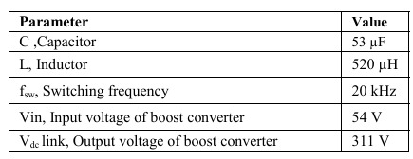

Table 2. Values of boost converter

The boost converter operates in 2 modes: charging, discharging of responsive components. In the first mode of operation, the switch is turned on, and the Inductor is charging to a certain level. To supply this load, flip this switch to the "off" place and discharge the responsive component into the output.

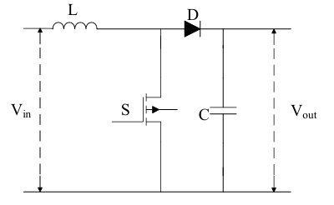

# 

# Fig.2: Structure of boost converter

1. ***First operation mode (0<t<toff)***

While the switch is operating. At a point, the switch is in the "on" position, and the diode is reverse biased. The inductor current is gradually raised from min to max throughout the ton interval until the switch is switched off. Turning off the SB activates the second one operating modes.

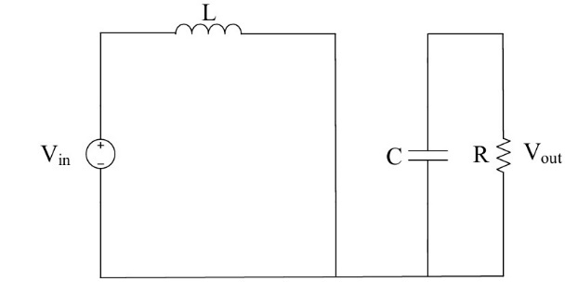

# 

# Fig.3: Boost converter structure while the switch is "on"

# 

## Second operation mode (toff <t<Ts)

This Given voltage is increased by this vitality stored in this inductor, that is forward bias diode and exiting this condenser given to the load. As a result, in comparison to this input voltage, the output voltage increases. At this interval, this mean i/p voltage is lower than the o/p voltage, which is measured at the system result. This keeps happening till the IGBTs is turned on once more. From the maximum value to the least value, the current flowing through the inductor drops. When the switch is in the "off" position, the converter's output won't be increased to the desired level if the charge current of Inductor is less than what is needed to give the output.

It is necessary to compute the values of the inductor and capacitor to avoid the converter functioning in not continuous working mode. consequently, it is guaranteed that at every interval, the converter's output voltage is higher than the input voltage.

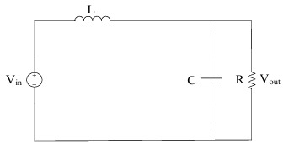

# Fig.4: Boost converter Structure while the switch is "off"

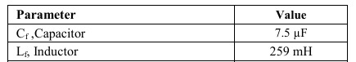

Table 3. Parameters of LC filter

1. **MPPT Controller**

To improve the performance of a solar photovoltaic system, this study used a Modified Perturb and Observe (P&O) method for Maximum Power Point Tracking (MPPT). The algorithm was created to modify the duty cycle (D) of a DC-DC converter so that solar panels can function at their maximum power point under a variety of environmental situations. The suggested technique starts with an initial duty cycle (Dinit) and modifies it within a specified range (Dmin to Dmax) using real-time voltage (V) and current (I) data.

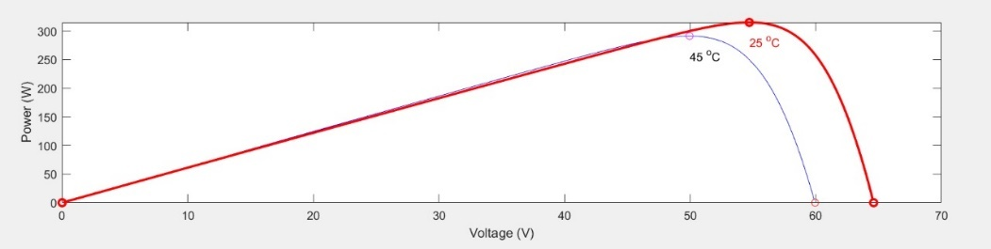

# 

# Fig.5: P–V curve of a PV panel

The algorithm computes the differences in power (dP) and voltage (dV) between iterations.Depending on the sign of dP and dV, the duty cycle is increased or decreased by a tiny adaptive step (deltaD) scaled by the amount of the power change (M), which improves the algorithm's reaction to irradiance and temperature variations. This method reduces steady-state oscillations near the maximum power point, which improves tracking efficiency. The employment of a permanent memory function guarantees that earlier values (Vold, Pold, and Dold) are retained for more precise computations, resulting in steady and efficient MPPT operation.

1. **The H-Bridge Inverter controlled with the PI Controller**

This inverter converts dc-ac in order to obtain the correct output voltage and frequency level. This inverter output voltage has a periodic, non-sinusoidal waveform. This H-bridge ckt architecture has 4 switching devices, a dc sources. The output voltage waveform is generated using one of four possible switching scenarios.

Pulse width modulation (PWM) is a frequent switching technique for acquiring these conditions. There are several different PWM approaches. This SPWMs is the very widely use approach, which is acquired by making comparison the sine wave ref and triangular waveforms.

This triangular waveform defines the inverter's frequency of switching. The reference frequency waveform directly affects this frequency of the output voltage of inverter. The ref waveform is use to change this duty fraction of this switch. The PI controller reduces oscillation in the output voltage.

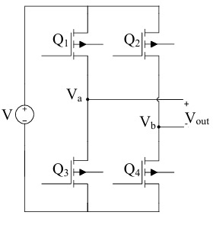

# 

# Fig.6: Diagram of H-bridge inverter

This reference voltage signal is in contrasted to the resulting voltage signal and utilized as feedback. This PI controller's modulation index value is calculated by determining the distinction between two signals for its input. The index of modulation is multiplied by the sinusoidal ref wave and compared with the triangle wave. This switch pulse is created behalf of the H-bridge inverter. In this study, the Kp value is equal to 0.0002, and the Ki value is equal to 0.1. This value is being found using Ziegler-Nichols’s algorithm.

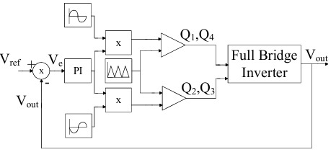

# 

# Fig.7: Generation of switching pulse controlled with PI controller

1. **LC Filter**

This use of an LC filter of an inverter system reduces Vout harmonics.

Harmonic output voltages might result in poor power quality. This LC filter is efficient in obtaining peak power quality by minimizing harmonic content.

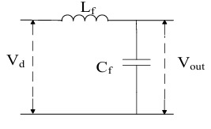

# 

# Fig.8: Structure of LC filter

**II. SIMULATION USING MATLAB AND ITS RESULTS**

This PV system Modelled by the MATLAB Simulink Software is shown in Figure. where the Photovoltaic board is position on the LHS, this boost converter is at following to the Photovoltaic panel. H bridge inverter has been positioned near the boost converter. Alongside, the LC sludge was placed next to the H-ground inverter. The temp, irradiation is not changed for the modelled PV system.

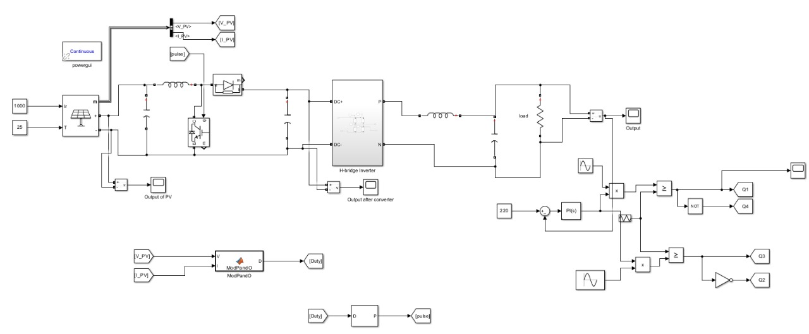

**Fig.9: Modelling of inverter base PV system in MATLAB**

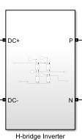 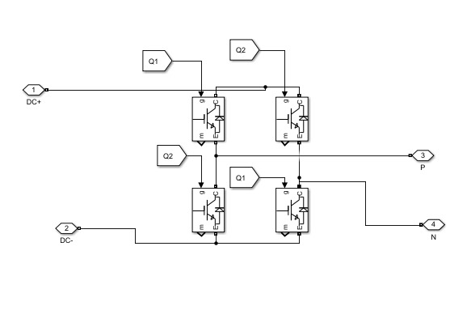

**Fig.10: Block diagram of H-bridge**

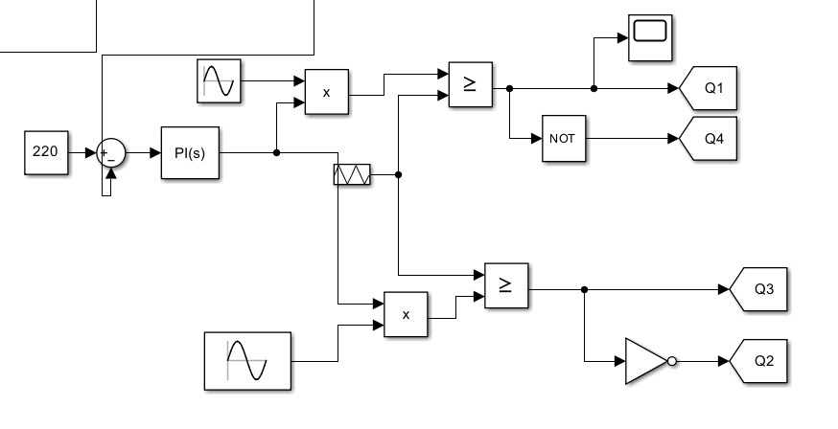

**Fig.12: SPWM switching pulse generations by PI controller**

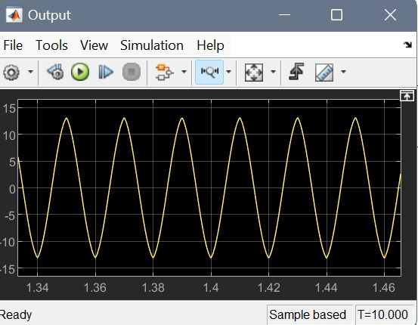

**Fig.12: Output across load**

**III. Conclusion**

This paper uses MATLAB Simulink to describe an inverter-based photovoltaic (PV) system in detail. The system is developed to transform solar-generated DC electricity into AC power, with grid-tied applications in mind. An H-bridge inverter managed by a PI (Proportional-Integral) controller for effective DC-AC conversion comes after a micro inverter with a boost converter to increase the input DC voltage. Even in situations with fluctuating solar irradiation, the PV panels' maximum energy extraction is guaranteed by the employment of an Incremental Conductance Maximum Power Point Tracking (MPPT) algorithm. For single-phase applications, the system efficiently maintains a clean and constant sine wave output at 220V RMS. In order to fulfil power quality requirements, an LC filter is being added to the inverter output to further improve the quality of the power by lowering harmonics. These findings of the simulation demonstrate the system's resilience and its capacity to provide a steady 315W power output while adjusting to shifting environmental circumstances.

**IV. REFERENCES**

[1] Ersan KABALCI1, Aydin BOYAR1, “Design and analysis of micro inverter for PV plant, ECAI 2017 - International Conference – 9th Edition.

[2] N.L. Panwara, S.C. Kaushikb, S. Kotharia, “Role of renewable energy sources in environmental protection: A review”, Ren.Sus. En. Rew vol. 15, 2011, pp. 1513–1524.

[3] E. Kabalci, A. Gorgun, “Design and implementation of a PI-MPPT based buck-boost converter”, ECAI 2015 - Bucharest, ROMÂNIA, pp. 23-28.